Titanic:

Creating Google Sheets API:

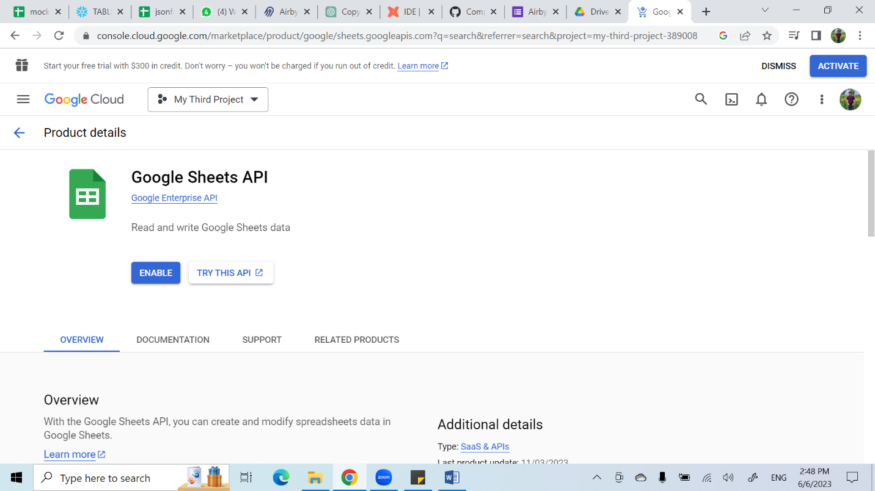

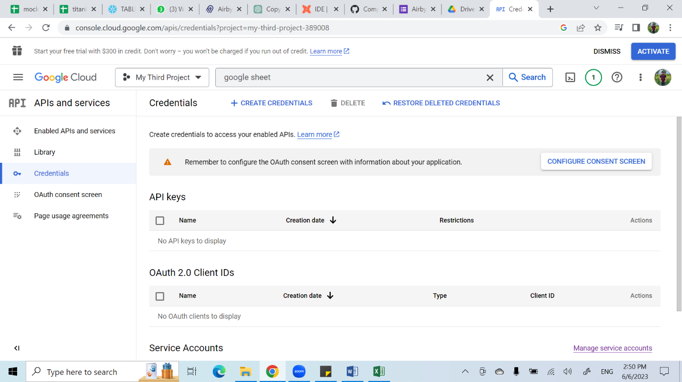

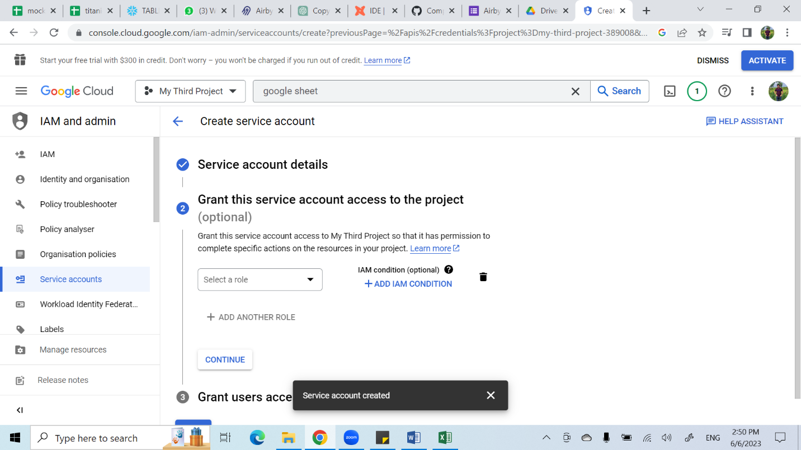

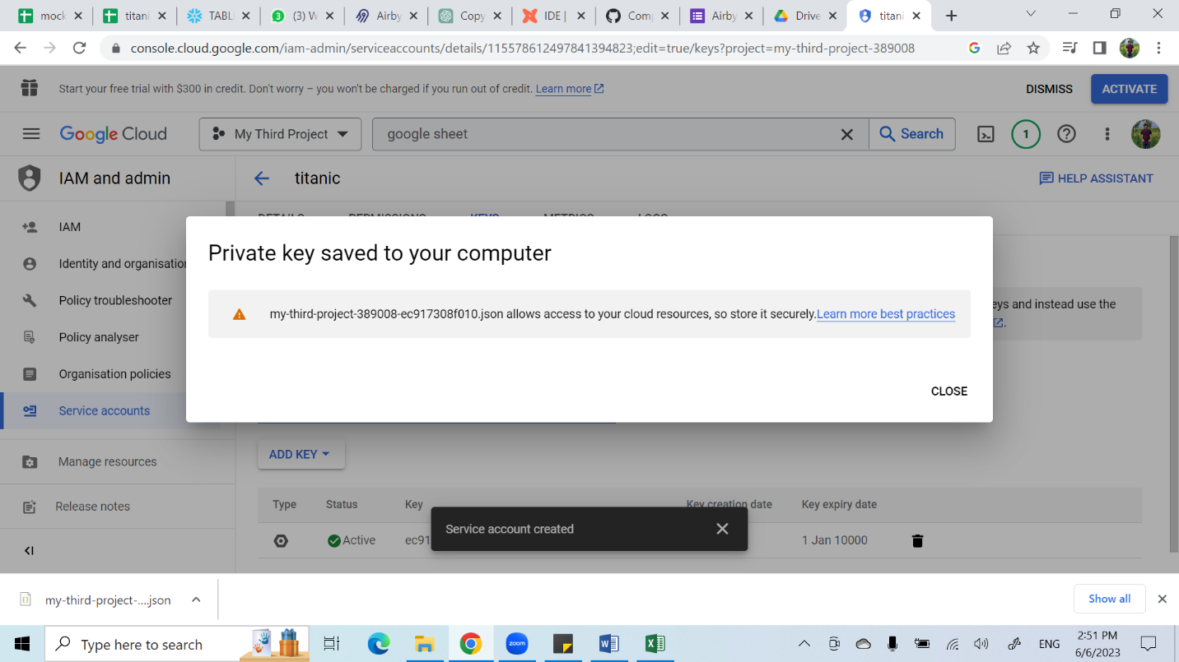

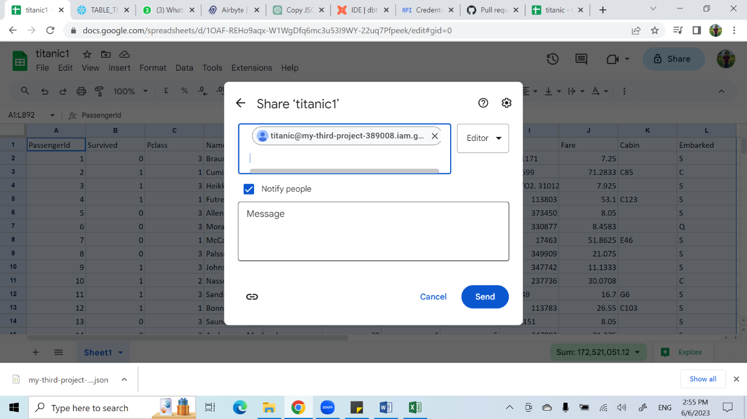

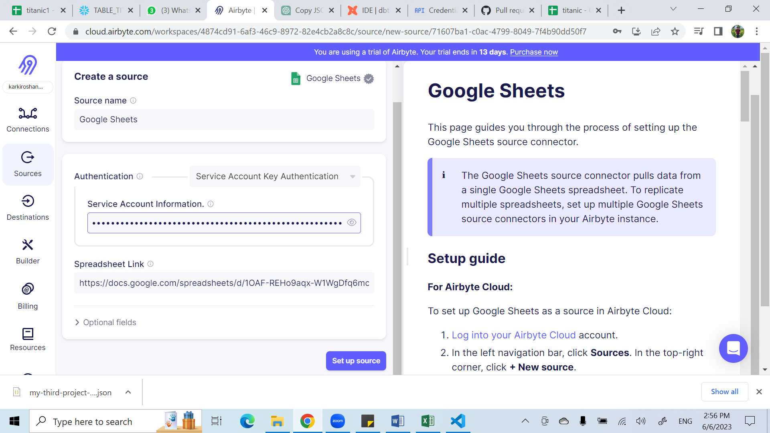

As we can see database and schema where we can keep our data.

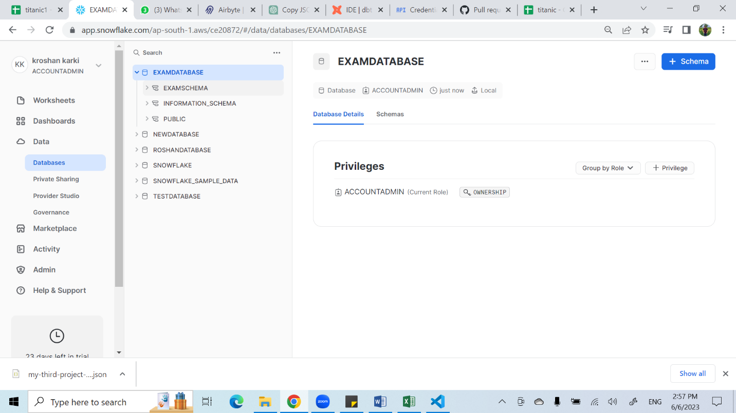

Creating the Sources:

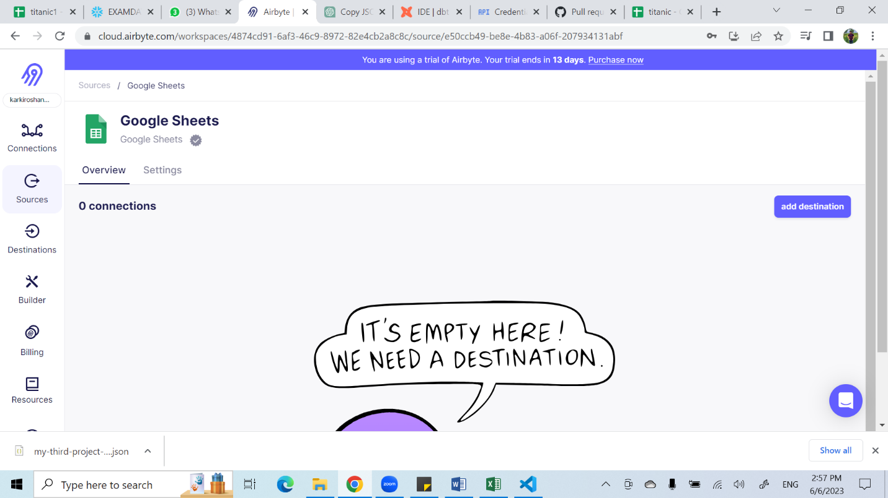

Now, adding the destination to that sources:

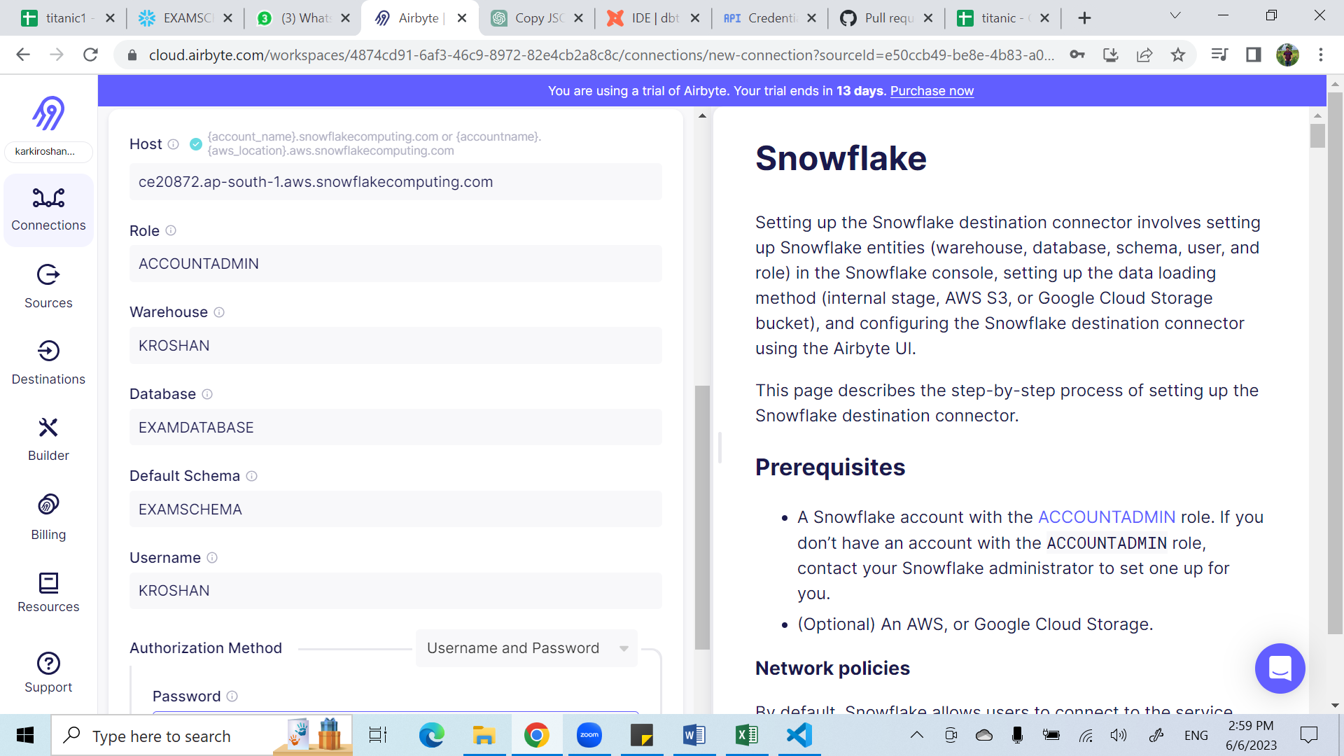

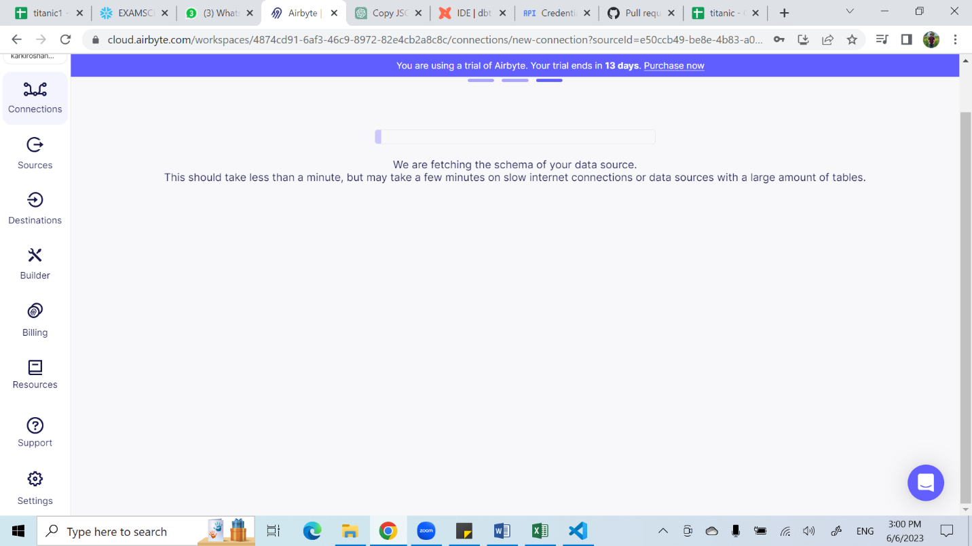

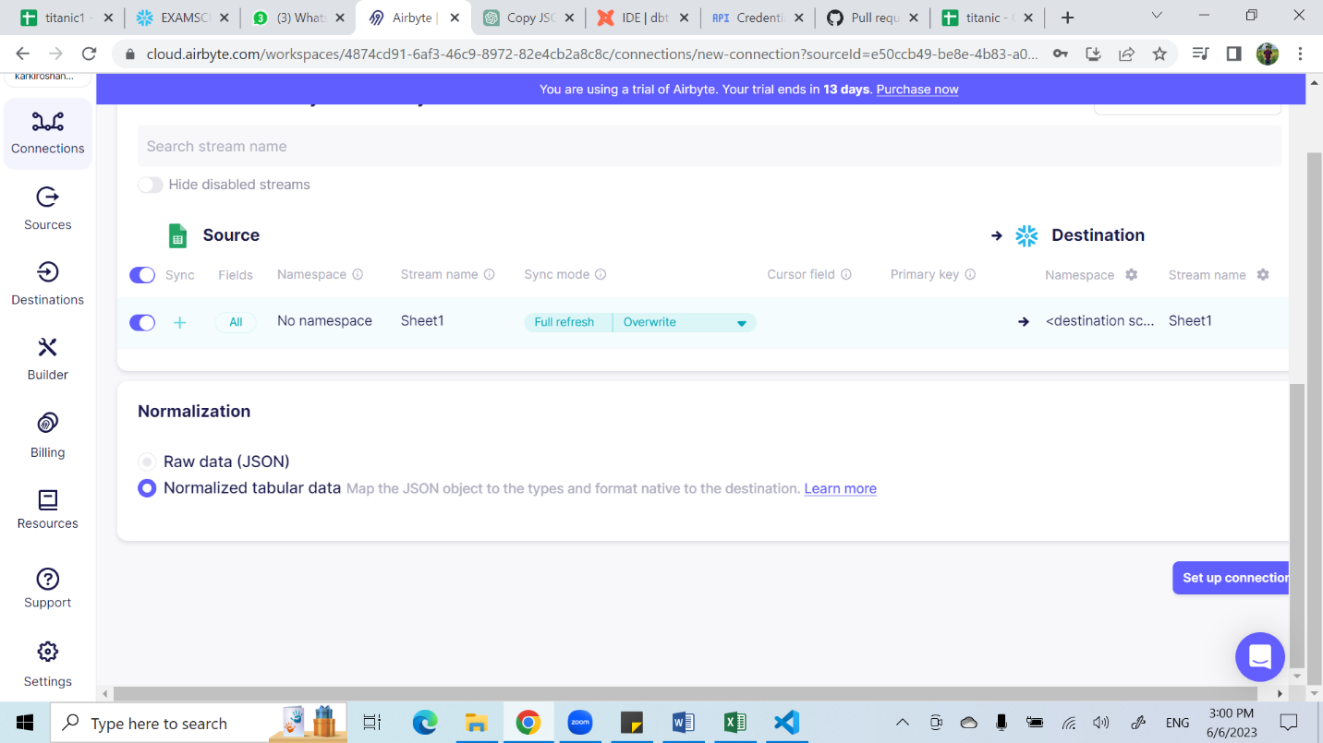

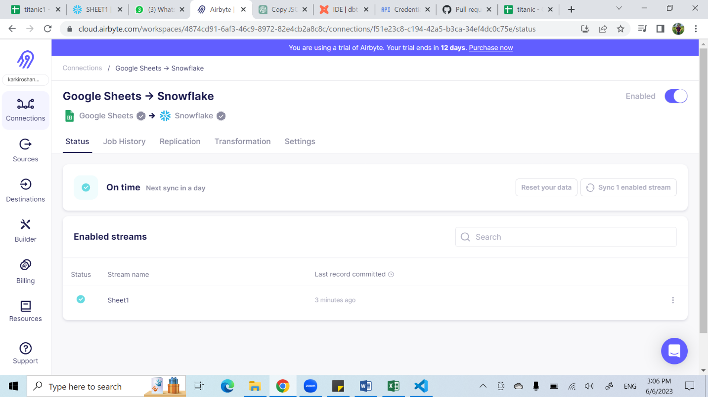

Doing the queries:

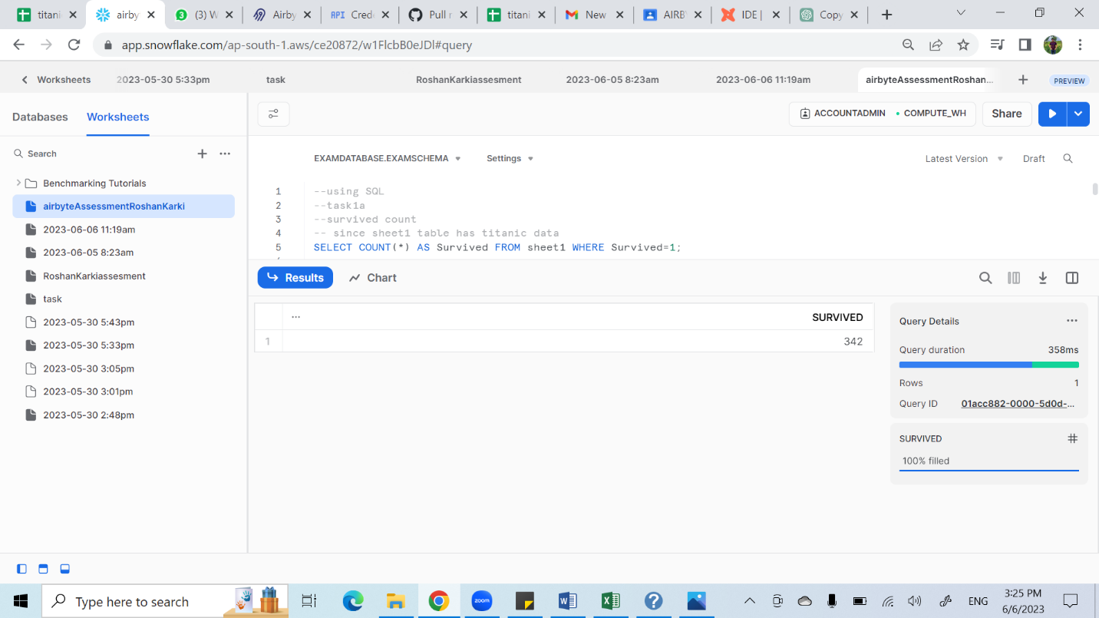

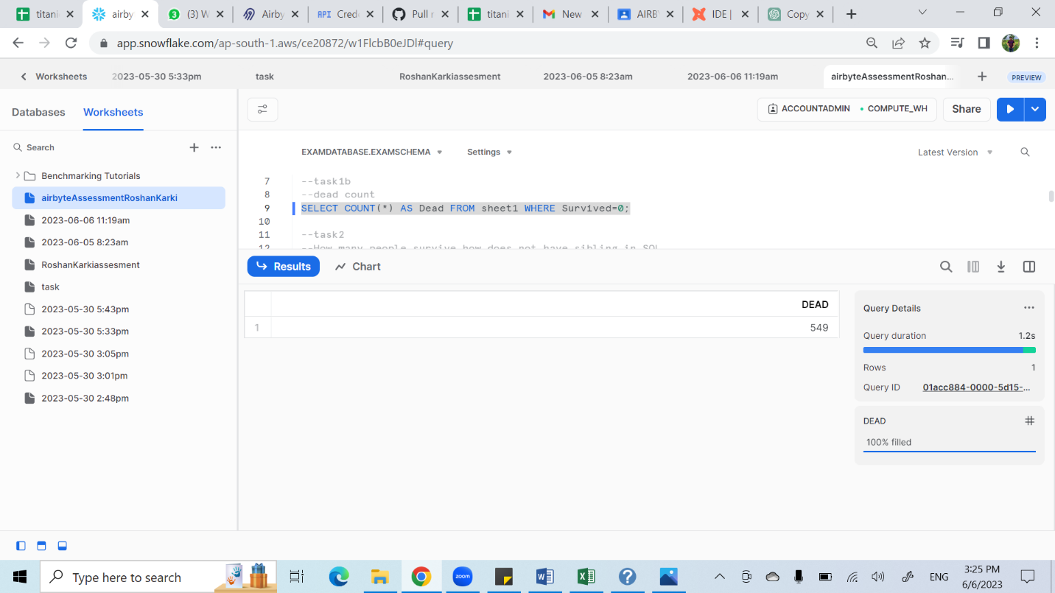

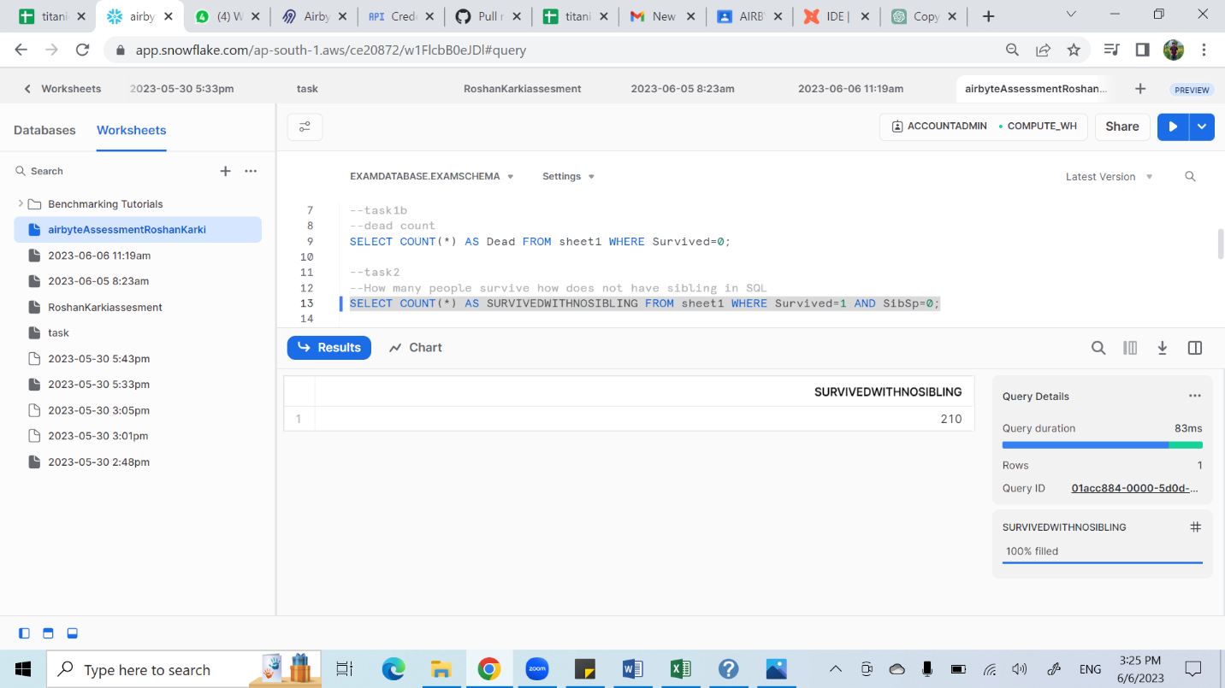

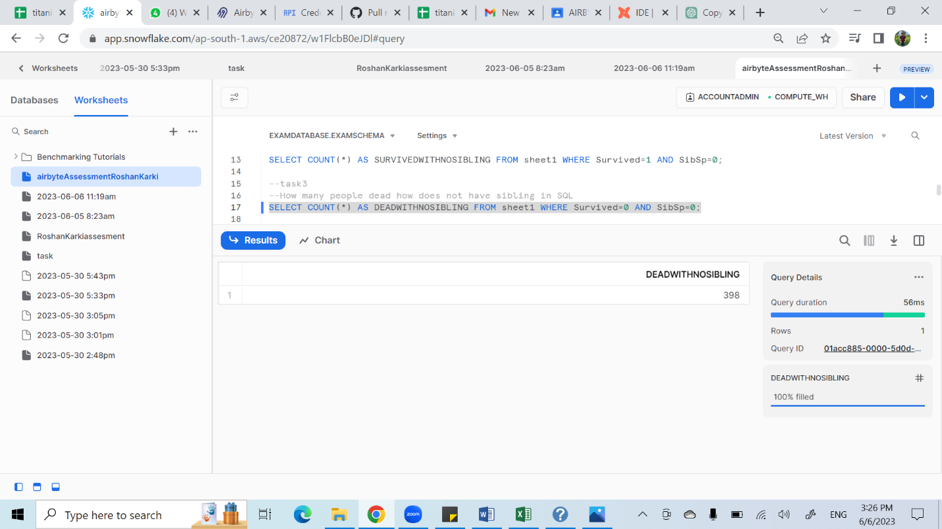

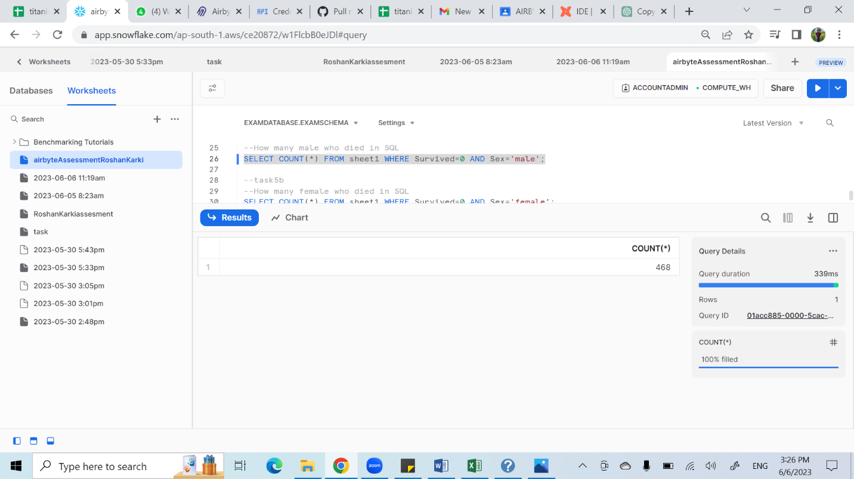

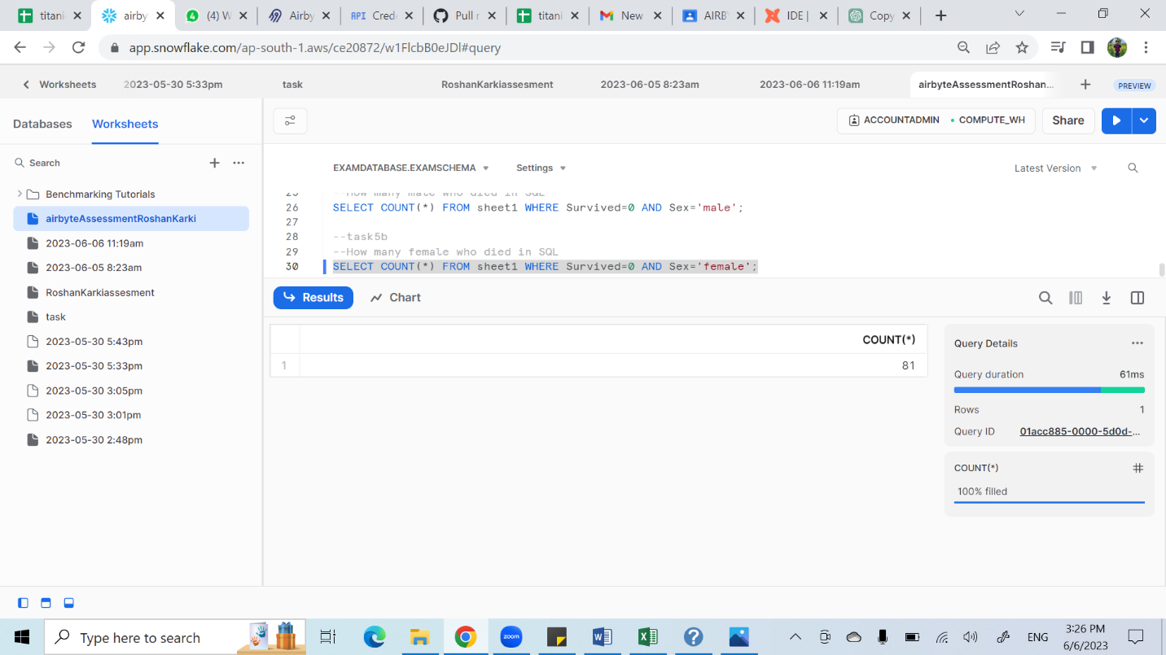

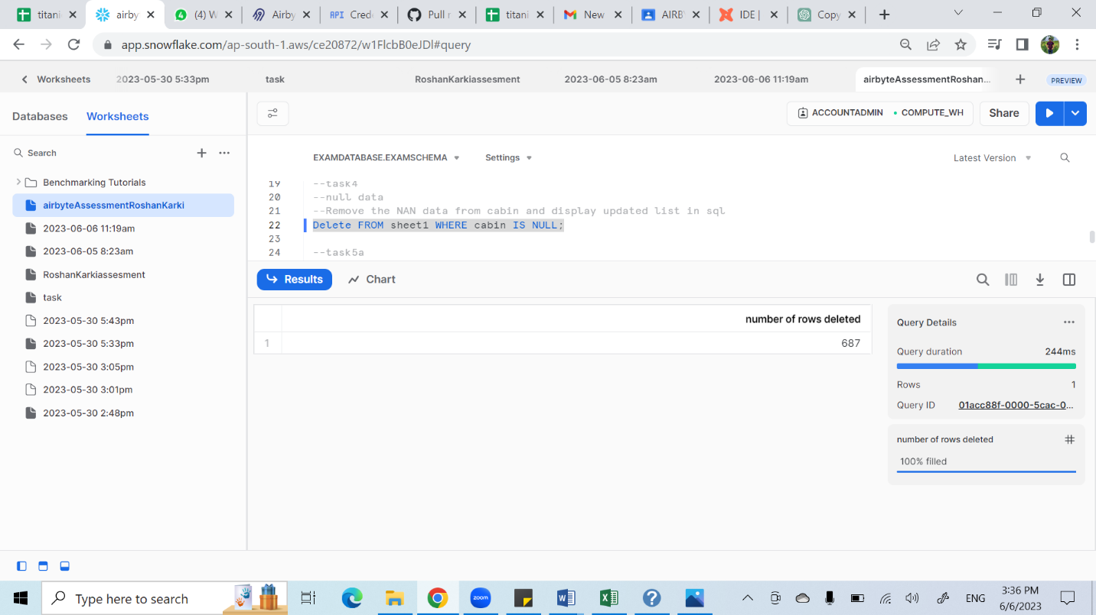

2. Reading this csv file

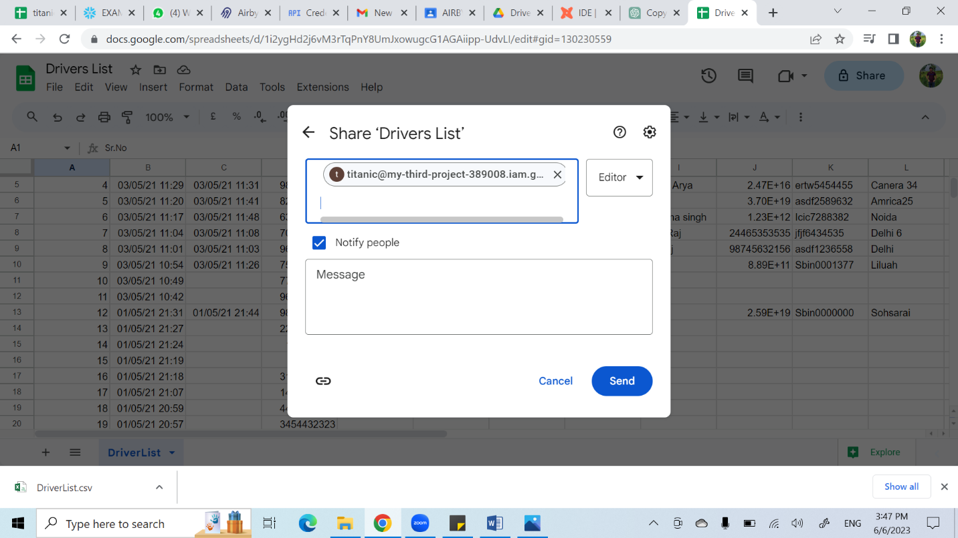

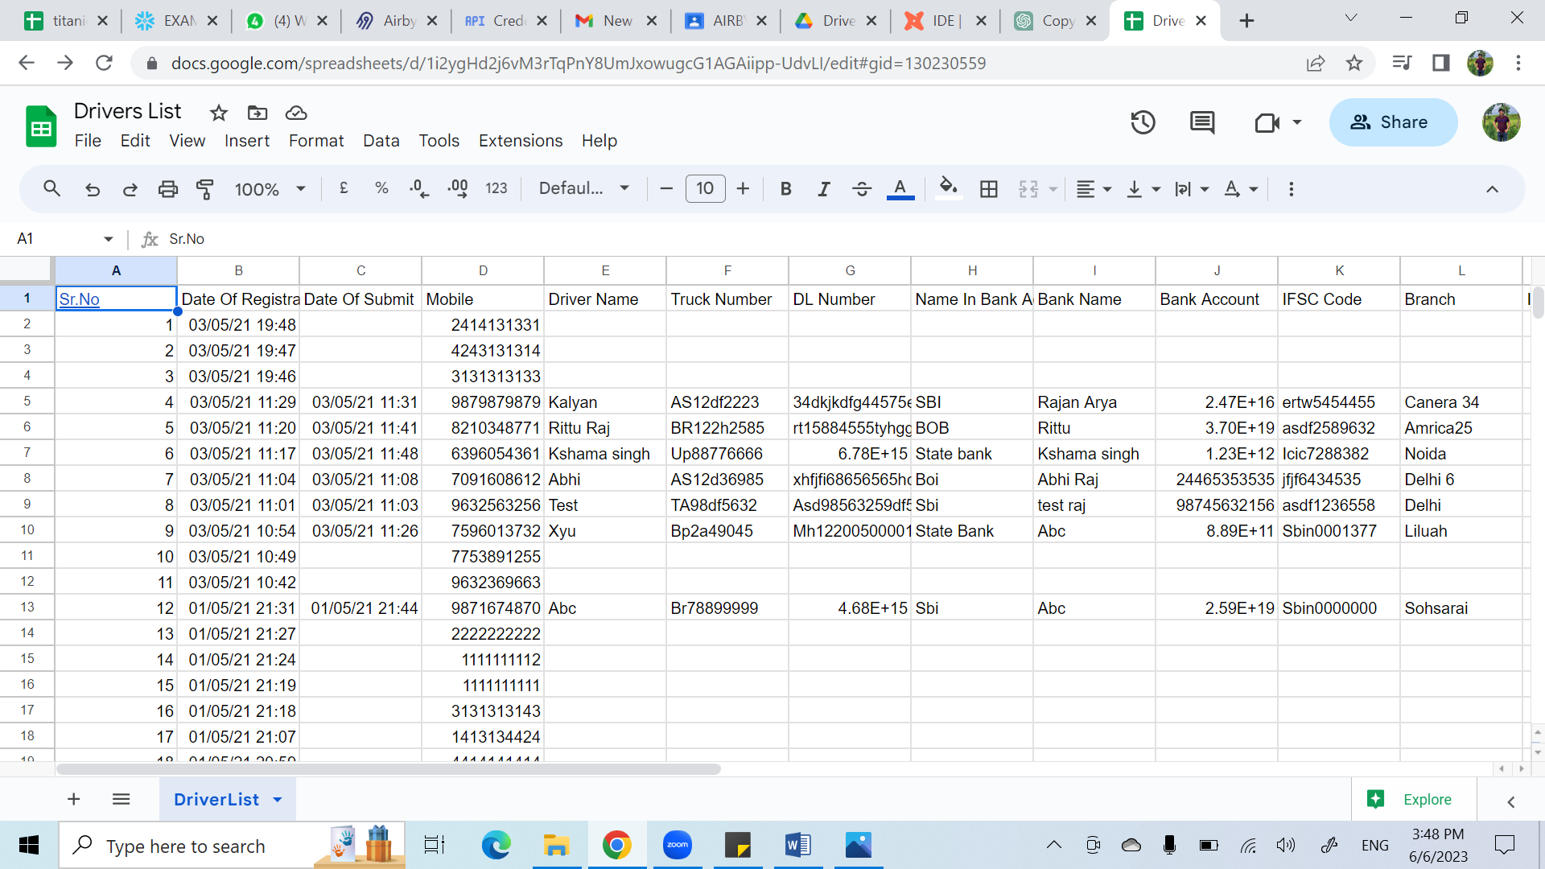

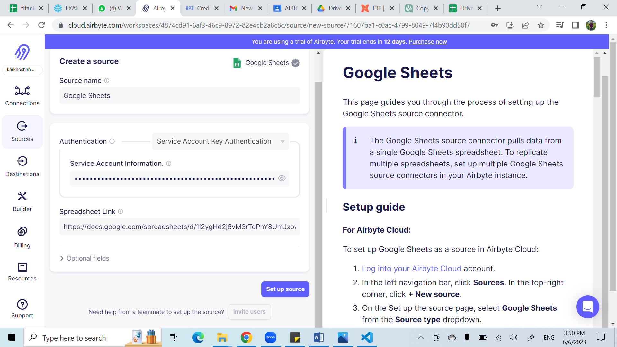

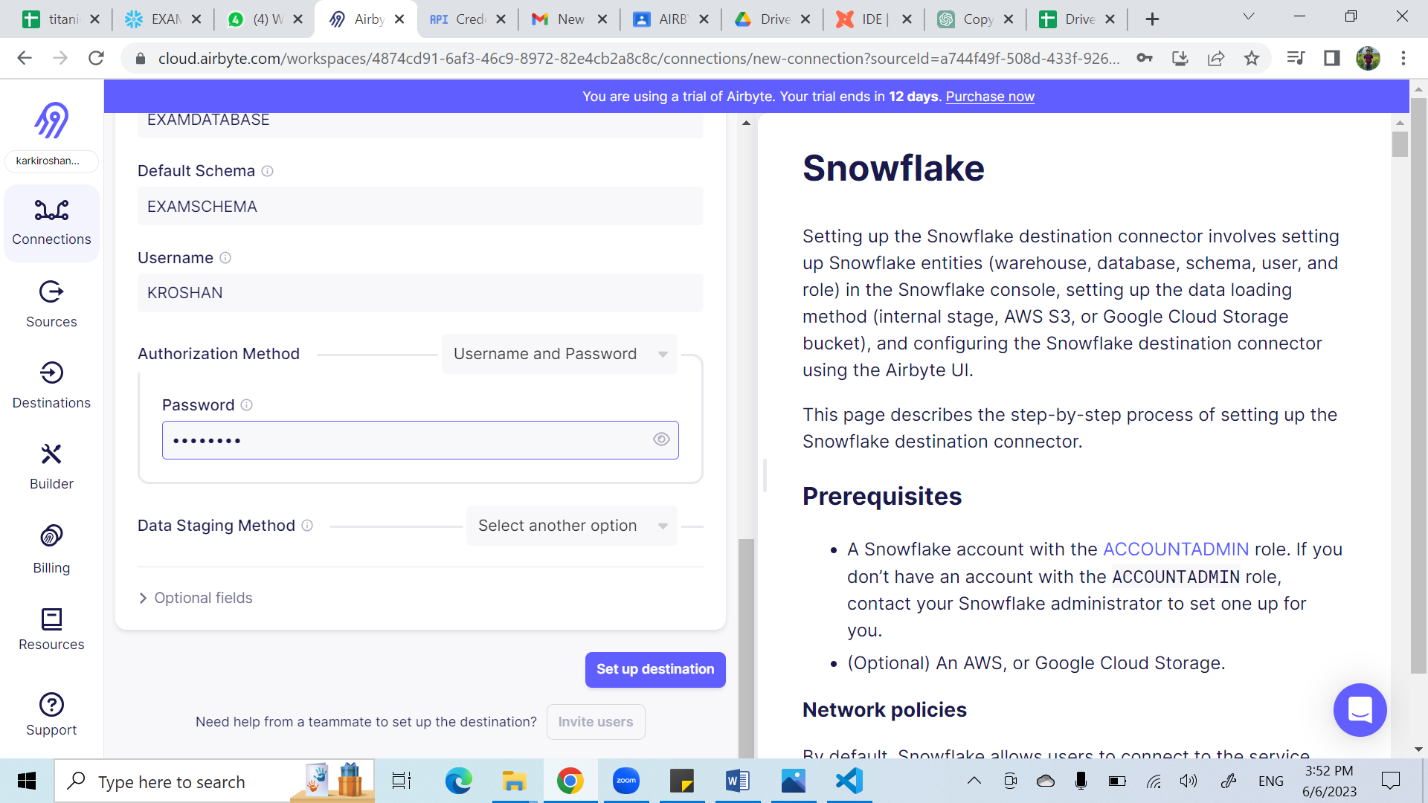

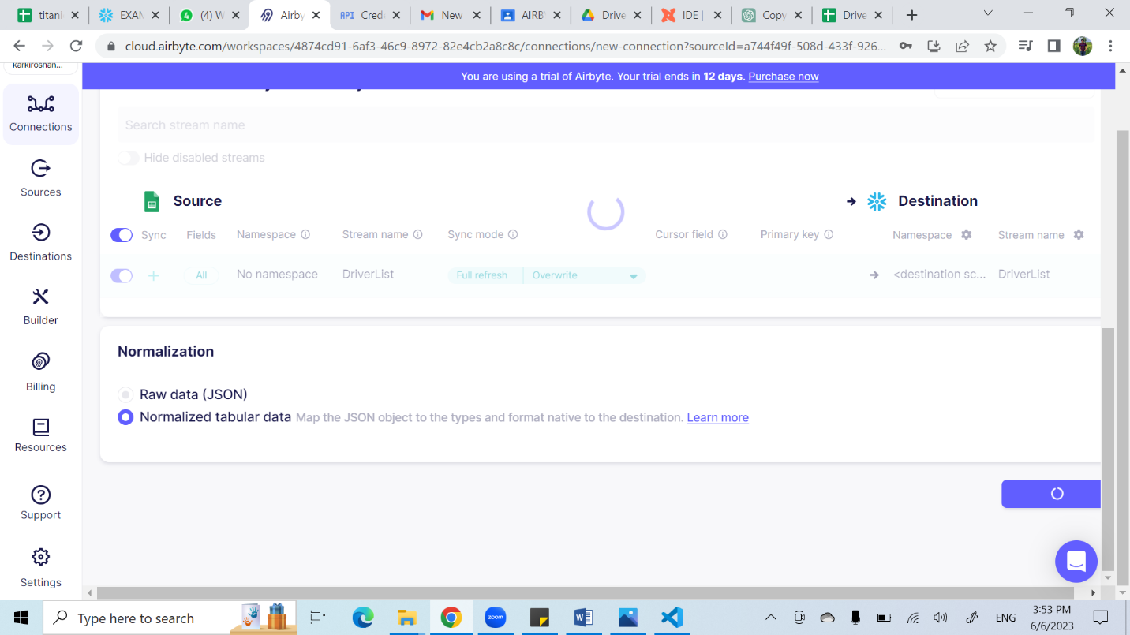

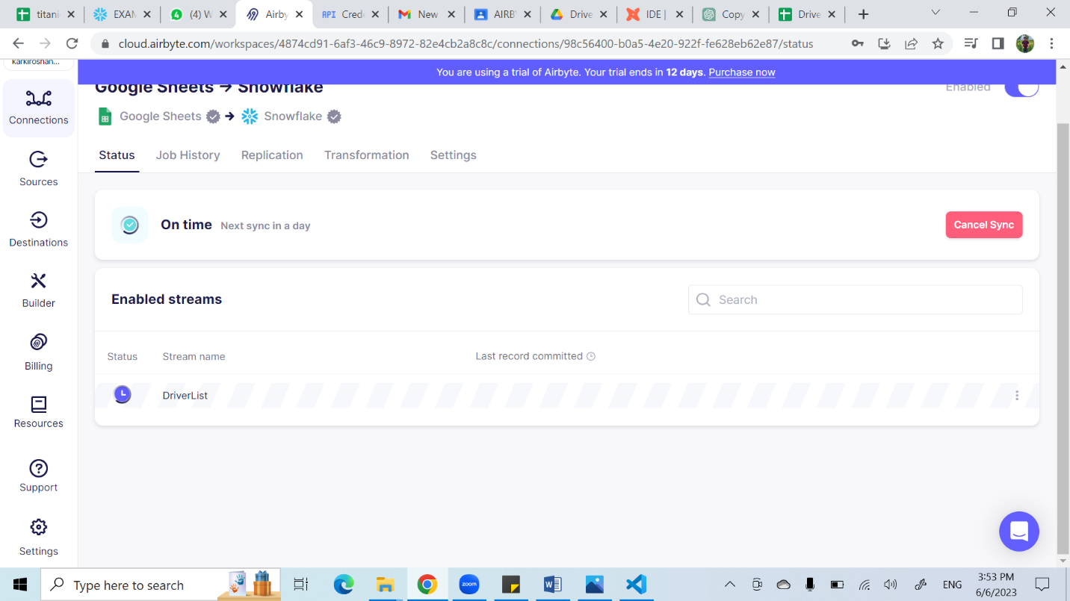

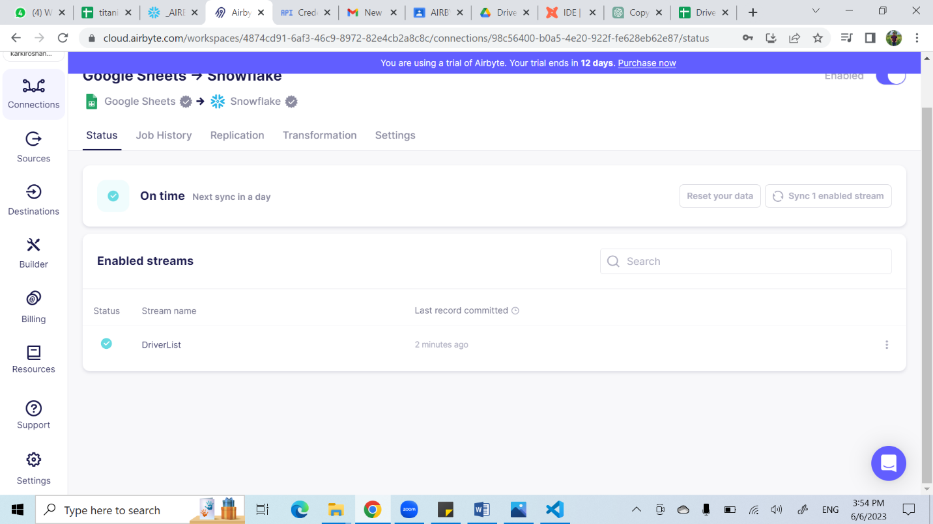

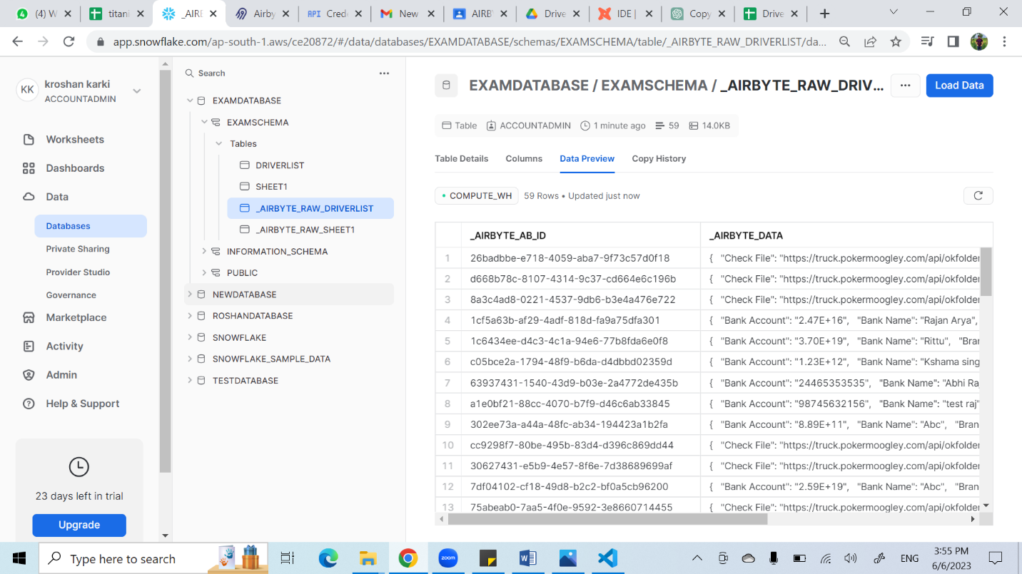

1.How many driver name starts from N?

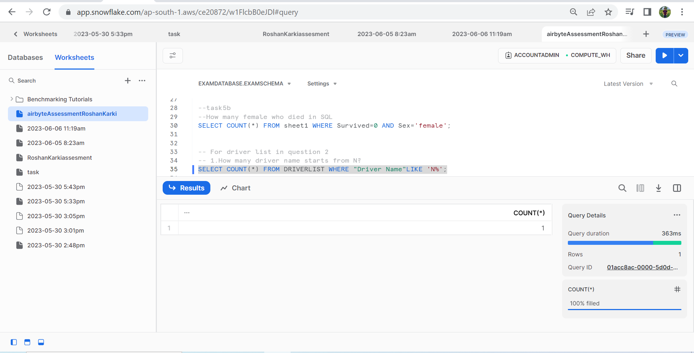

2. Display the data which does not null records

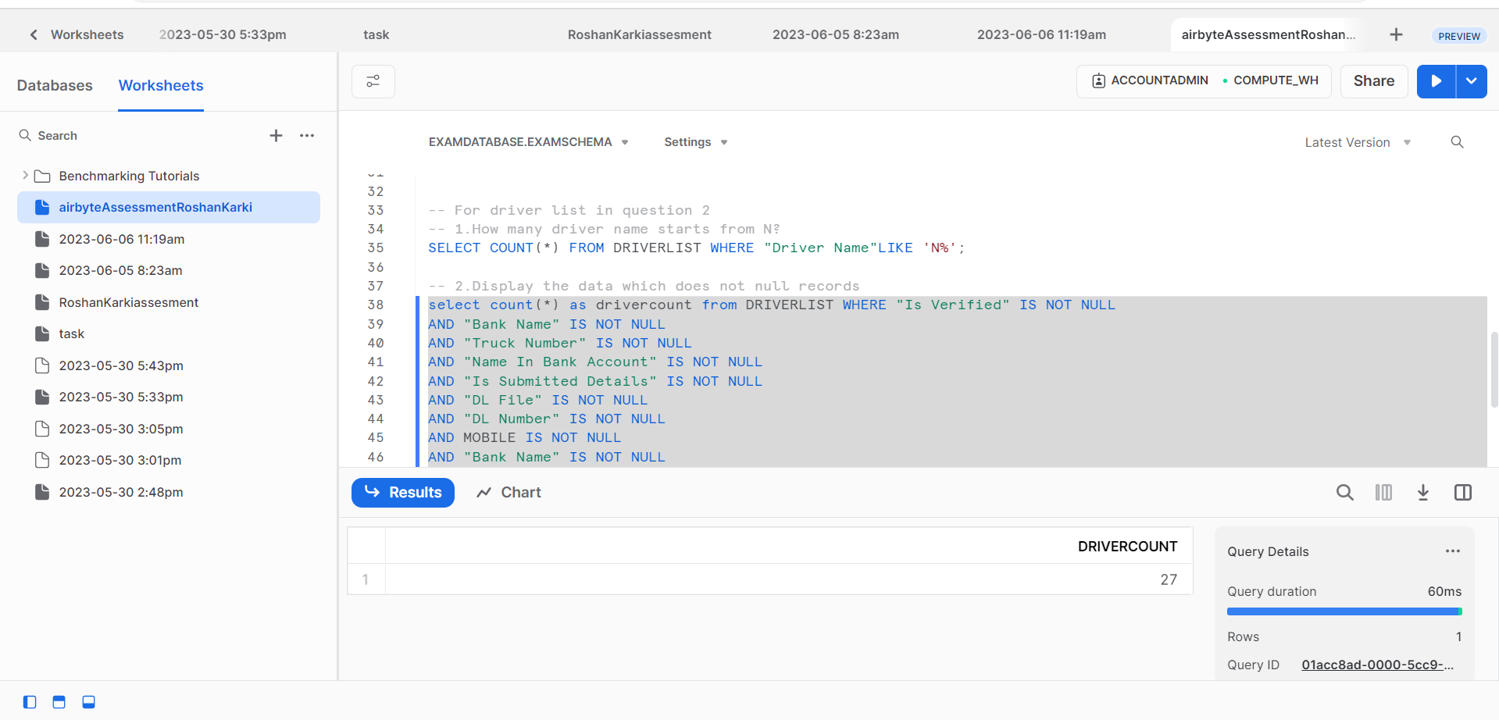

Displaying the Data:

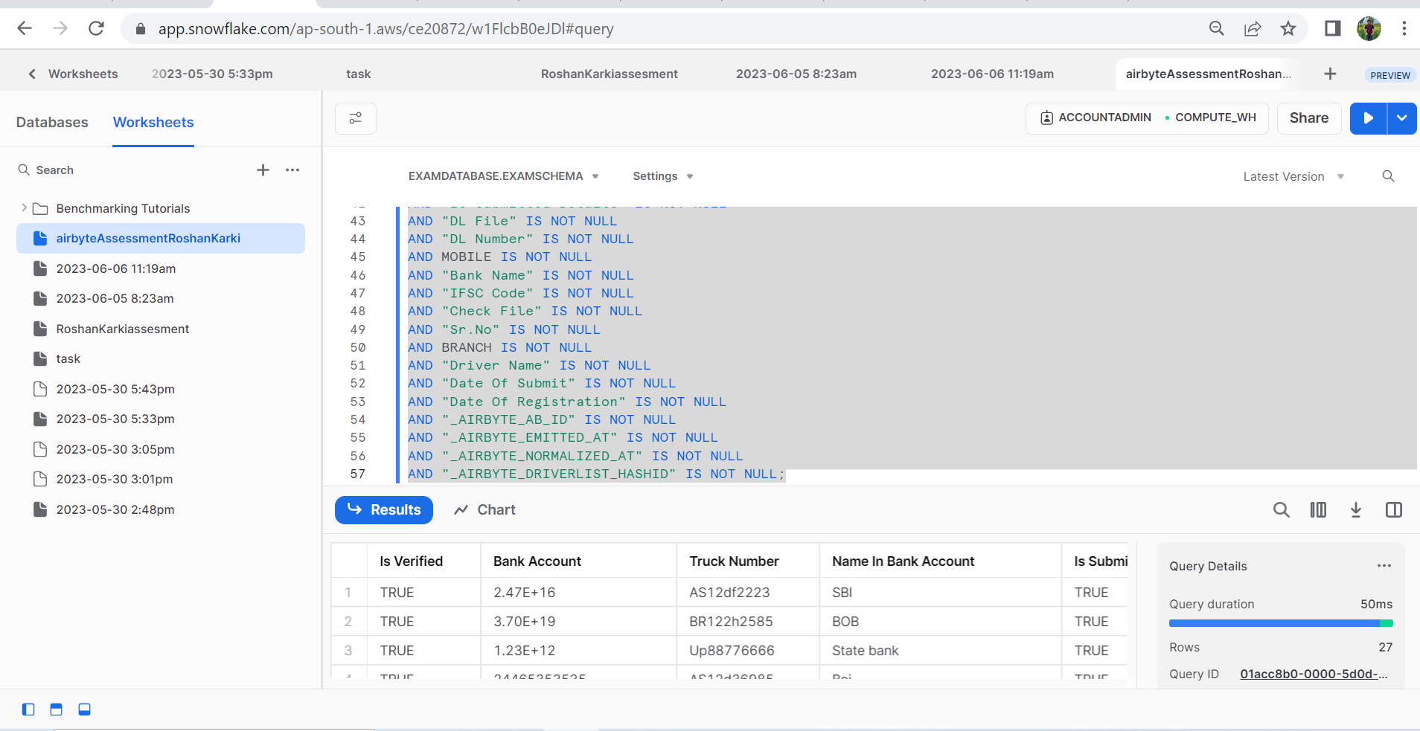

Query for both questions:

--using SQL

--task1a

--survived count

-- since sheet1 table has titanic data

SELECT COUNT(*) AS Survived FROM sheet1 WHERE Survived=1;

--task1b

--dead count

SELECT COUNT(*) AS Dead FROM sheet1 WHERE Survived=0;

--task2

--How many people survive how does not have sibling in SQL

SELECT COUNT(*) AS SURVIVEDWITHNOSIBLING FROM sheet1 WHERE Survived=1 AND SibSp=0;

--task3

--How many people dead how does not have sibling in SQL

SELECT COUNT(*) AS DEADWITHNOSIBLING FROM sheet1 WHERE Survived=0 AND SibSp=0;

--task4

--null data

--Remove the NAN data from cabin and display updated list in sql

Delete FROM sheet1 WHERE cabin IS NULL;

--task5a

--How many male who died in SQL

SELECT COUNT(*) FROM sheet1 WHERE Survived=0 AND Sex='male';

--task5b

--How many female who died in SQL

SELECT COUNT(*) FROM sheet1 WHERE Survived=0 AND Sex='female';

-- For driver list in question 2

-- 1.How many driver name starts from N?

SELECT COUNT(*) FROM DRIVERLIST WHERE "Driver Name"LIKE 'N%';

-- 2.Display the data which does not null records

select * from DRIVERLIST WHERE "Is Verified" IS NOT NULL

AND "Bank Name" IS NOT NULL

AND "Truck Number" IS NOT NULL

AND "Name In Bank Account" IS NOT NULL

AND "Is Submitted Details" IS NOT NULL

AND "DL File" IS NOT NULL

AND "DL Number" IS NOT NULL

AND MOBILE IS NOT NULL

AND "Bank Name" IS NOT NULL

AND "IFSC Code" IS NOT NULL

AND "Check File" IS NOT NULL

AND "Sr.No" IS NOT NULL

AND BRANCH IS NOT NULL

AND "Driver Name" IS NOT NULL

AND "Date Of Submit" IS NOT NULL

AND "Date Of Registration" IS NOT NULL

AND "_AIRBYTE_AB_ID" IS NOT NULL

AND "_AIRBYTE_EMITTED_AT" IS NOT NULL

AND "_AIRBYTE_NORMALIZED_AT" IS NOT NULL

AND "_AIRBYTE_DRIVERLIST_HASHID" IS NOT NULL;